December 2017/ Kislev/Tevet 5778

Join Us for Our Chanukah Party!
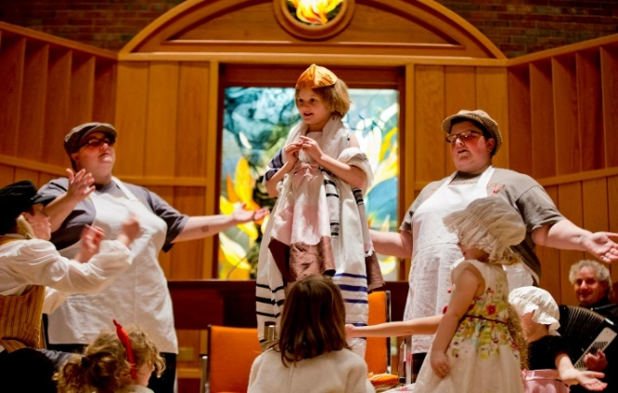
Sunday, December 17th, 2017, 4:00 pm
Mega-Menorah lighting,
followed by a catered dinner, music, games,
plus, a heart-warming Chanukah play performed by our Hebrew School!
Special Guest Performance by the Maine Music Society Chorale!
Remember to bring your Menorahs
and Chanukah Candles so we can all enjoy the light together!
Crafts and dreidel games available for the kids.
It’s LATKE TIME ~ See you there!
Suggested Donation: $8 for members, $10 for non-members, children free
RSVP – 786-4201 or temple6359@aol.com

From the Rabbi, December 2017

Hi Everyone:

“But we, and our fathers, [and our mothers], have sinned.”

So reads the introduction to the short confession—Ashamnu, bagadnu—that we recite several times over the course of Yom Kippur. Our new prayer books are careful to add the words “and our mothers” here, as they do whenever we recite the traditional formulation: “our fathers.”

This comes up most often when we identify God as the God of our fathers. We now also include God as the God of our mothers as well. (This is less of a problem in translation—we typically just say our ancestors—but the traditional Hebrew word “Avotaynu,” refers only to male ancestors.)

I thinks this change is very important—women should never feel belittled by our prayers—yet when I first encountered the new formulation for the short confession, it struck me as odd that in our admirable quest to be inclusive of women, we now actually go out of our way to insist that our mothers are also sinful! Couldn’t we have just left that one phrase unchanged?

Last Friday night, we honored America’s Veterans with a special Shabbat service. The service included reading 5 or 6 poems that emphasized the difficult sacrifices our soldiers make on our behalf. After the service, Charlie wondered why all the poems assumed that our soldiers are all male. She was hurt, and she felt belittled.

The argument is often made that military service is an obligation that women should feel grateful to be exempt from. But that is not how it seemed to Charlie.

True egalitarianism is just that. Women can fight—and die—for our country, the same as men, and, yes, women sin just like men do. To ignore this realty is to belittle women.

As a boy growing up in a Hasidic environment, I was often jealous of the girls. After all, they didn’t have to spend hours upon hours in shul every Shabbat, or go to school until 6 p.m., or go to school on Sundays, or prepare an entire Torah portion for their Bat Mitzvahs…

Now I know better.

Rabbi Sruli

PS Rabbi Sruli will deliver the Invocation at the Inauguration of Auburn Mayor, Jason Levesque, on Monday, December 4 at 6 p.m. Rabbi Sruli and Lisa will be performing with the Maine Music Society for their Annual Heritage Holidays concert on Saturday, December 9 at 7:30 P.M. and Sunday, December 10 at 3:00 P.M. These concerts are open to the public. Tickets can be purchased at the Maine Music Society website. Rabbi Sruli and Lisa will be performing at the Holiday party for the residents of Clover Manor on Thursday, December 14 at 6 P.M. Rabbi Sruli will also lead Chanukah services for the entire pre-school as well as the Jewish residents of Clover Manor on Friday, December 15 at 10 A.M.

PRESIDENT’S MESSAGE

As you know, last year we raised enough money so that we did not have to access any funds from our investments. As of now, this year we will have to take tens of thousands out of our investments. This Kol Nidre we raised less than $10,000. That is less than a third of what we raised last year.
If the Temple means something to you....if you want the Temple here for you and your loved ones....if you want this Jewish Community to survive, you need to open your hearts and your wallets and give to Temple Shalom. If you have not donated this year, please donate now. If you have donated, please donate more. We always need you and your participation, but today, now, right now, we need your money.
The continuation of our Jewish Community is the reason for our existence. Ensuring we have a place to pray, a place to congregate and a place to be buried is important to all of us. Doing this is not free. It costs a lot of money to maintain our community and we need you to look into your hearts and open your wallets. Whatever you have given or whatever you are thinking of giving, can you give a little more? You are the reason for the Temple to be here. Can you be the reason for our continued existence? Can you open your hearts? If you do not open your hearts and your wallets now, will you be able to look in the mirror and say that you did all you could do? Will you be the reason for our continued success or the reason for a financial downfall?
Anything you can do helps, but the more the better? At Kol Nidre, I asked that each think about giving 18%, 10% or 8.1% more than last year. If you cannot do an increase, can you at least donate what you did last year?
I know many are on fixed incomes, but please do a little more. Maybe go out to dinner a little bit less?
Because of your generosity, we have a Rabbi, an active Temple in Central Maine...a Jewish Community. Be the reason for our financial success. Open your heart and wallets and give today.
We made great strides last year with your generosity. Without your continued generosity, we will just loose the financial ground we made up last year. To put us in good financial shape, we need to have a few years where we do not touch our investments. We need to let our money grow. To do this, we need you to donate. We need you to donate today. Don't put it off. Don't just read this and put it off. Take action today. Donate today!
Send in a check or let us know how much you will be donating on a monthly basis for a commitment this year. You can call or email the office (Temple6359@aol.com, 207-786-4201) or me (David@AllenMfgUSA.com or 207-333-3385). Thank you!

!!!!!!!!!!!!!!!BOOK GROUP NEWS!!!!!!!!!!!!!

Secret of Nightingale Palace by Dana Sachs. Even though the novel started a bit slow, it soon sucked you right in with the back story and character development. Was this really a road trip story of an estranged woman and her granddaughter? Is it about family secrets? Or cultural divides? Or overcoming grief? Maybe class differences? Is it the destination or the journey that’s most important? The answer is “Yes.” And the secret? Pick up the book and go on this journey yourself. All will be revealed. You won’t be disappointed.
Our next book is The German Girl by Armando Lucas Correa. I’m hearing rave reviews from those who have already read it. Amazon gives it 4.3 stars and describes it like this:

“A young girl flees Nazi-occupied Germany with her family and best friend, only to discover that the overseas refuge they had been promised is an illusion in this “powerful and affecting” (Kirkus Reviews) debut novel, perfect for fans ofThe Nightingale, All the Light We Cannot See, and Schindler’s List.”
Before everything changed, young Hannah Rosenthal lived a charmed life. But now, in 1939, the streets of Berlin are draped with red, white, and black flags; her family’s fine possessions are hauled away; and they are no longer welcome in the places that once felt like home. Hannah and her best friend, Leo Martin, make a pact: whatever the future has in store for them, they’ll meet it together.
Hope appears in the form of the S.S. St. Louis, a transatlantic liner offering Jews safe passage out of Germany. After a frantic search to obtain visas, the Rosenthals and the Martins depart on the luxurious ship bound for Havana. Life on board the St. Louis is like a surreal holiday for the refugees, with masquerade balls, exquisite meals, and polite, respectful service. But soon ominous rumors from Cuba undermine the passengers’ fragile sense of safety. From one day to the next, impossible choices are offered, unthinkable sacrifices are made, and the ship that once was their salvation seems likely to become their doom.
Seven decades later in New York City, on her twelfth birthday, Anna Rosen receives a strange package from an unknown relative in Cuba, her great-aunt Hannah. Its contents will inspire Anna and her mother to travel to Havana to learn the truth about their family’s mysterious and tragic past, a quest that will help Anna understand her place and her purpose in the world.
The German Girl sweeps from Berlin at the brink of the Second World War to Cuba on the cusp of revolution, to New York in the wake of September 11, before reaching its deeply moving conclusion in the tumult of present-day Havana. Based on a true story, this masterful novel gives voice to the joys and sorrows of generations of exiles, forever seeking a place called home.”

So pick up your copy today and join us on MONDAY, DECEMBER 11 at 4 PM at the Temple……………..lesli

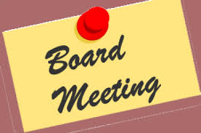

BOARD OF DIRECTORS MEETING
Our next meeting will be on
Monday, December 11, at 7:00 p.m.

ATTENTION. Temple Shalom live l’dor v’dor!!! To help support this ancient Jewish wish, the Temple Shalom Board has created a Legacy Committee. I am proud to have been asked by the Board to be its Chairperson. We are tasked to design and offer an inspiring and exciting workshop for all members and unaffiliated area Jews to answer any questions about implementing a legacy for Temple Shalom in your estate plans and wills. Until then, PLEASE feel free to contact me with any suggestions, questions or concerns you may have. Your inquiries will be confidential.
Dr. Elcha Buckman at 781-799-2110 and/or dr.elcha@yahoo.com

The
Shabbat Shalom
Orchestra

Calling all musicians!

If you love to play music you will love the Shabbat Shalom Orchestra.

The Shabbat Shalom Orchestra will play an amazing repertoire of lively and exciting Shabbat music for occasional Friday night services at Temple Shalom. Our first performance is planned for March 2017. This is a no-rehearsal band. Band members will receive PDF files of music for 5 or 6 pieces as well as audio files. The music will be in lead sheet form—melody and chords, for C and Bb instruments. We are looking for woodwinds, brass, strings of all sorts, percussion and keyboards and anything else that you might play.

If you are interested in joining the band, please contact Rabbi Sruli at djsruli@gmail.com.

All levels welcome.

Rabbi Sruli is always happy to speak with and meet with members or our Temple. Please call or text Rabbi Sruli on his cell phone at 914-980-9509 if you would like to speak with him or to arrange a time for a meeting. You can also call or leave a message at the Temple office and Rabbi Sruli will get back to you.

SPEEDY RECOVERY
We pray for refuah sh’leimah – the full and speedy recovery of Gary Buckman, John Calloway,
June Wilner Chason, Carson Hudson, Enid Ehrlich, Isaak Gekhtin, Anne Geller,Ariella Green,
Elizabeth Johnson, Mark Johnson, George Laskoff, Patti Levenson, Susan Lifter, Sandy Miller,
Ashley Olstein, Joel Salberg, Ruth Wilner Schloss, Rabbi David Ross Senter, Sandy Traister, Toby Wallach,
Neal Weiner, Betty Wise, Janet Zidle, David Izenstatt, Phil Bray, Michael Jesser, Debby Eicher,
Georgette Belanger, and all others who are not well at this time.

We like to hear good news! Whenever you request that a name be put on this list, please let Temple Shalom
know when it can be removed.

HAPPY BIRTHDAY TO
Estelle Rubinstein Dec 3
Andrew Bodenheimer 6
Joshua Goodman 7
Lillian Zidle 7
Briana Robillard 9
Peter Casares 10
Jennifer Nussinow 11
Carla Marcus 15
Gavin Piper 16
Suzan Katzir 17
Matthew Johnson 20
Sarah Levine 30
Patricia Suzanne 30

YAHRZEITEN

If you are observing a yahrzeit and are planning to come to Thursday morning minyan to say Kaddish, we urge you to contact Bob Laskoff (ral@laskofflaw.com) and let him know so that he can include that information in his weekly reminder email. It is your responsibility to call friends and neighbors to make sure there are enough people for the minyan.
We all enjoy our Thursday morning Minyans and breakfast schmoozes.
HELP! We need volunteers to shop and setup. A sign-up
sheet is in the kitchen.

DECEMBER 2017 YARTZHEITEN

Arno Fleisher December 2
Sonny Isaacson 4
Renee Laine 5
Morris Supovitz 6
Charles W. Marcus 11
Ernestine Friedlaender 13
Ethel Plavin 13
Morris Zallen 15
Morris Silverman 16
Frances Silverman 17
Jacob Shapiro 19
Frances Stern 19
Sylvia LaPerriere 20
Sylvia Day 21
Marcia Bell 22
Mazie Schwartz 22
William Scolnik 24
Jack Simon 24
Harry Drabkin 25
Keyla Fuks 27
Deborah Isaacson 29

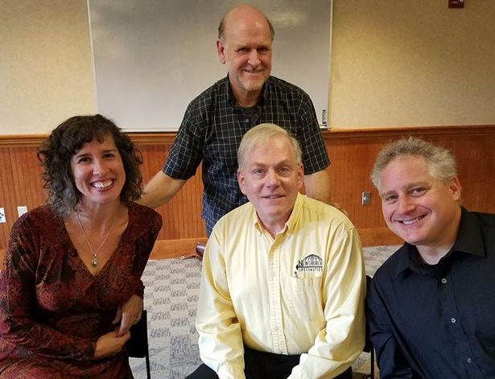
Last Multi-Faith Round Table at the Auburn
Public Library on Tuesday, December5, 12:30 P.M.

The Auburn Public Library is very excited to announce the return of the Multi-Faith Round Table discussions.

The final All-Clergy Round Table for 2017 will be on December 5.
All programs run from 12:30 to 1:30 p.m.

Rabbi Sruli will be joined by Pastor Roger Cousineau of East Auburn Baptist Church, Rev. Doctor Jody Cohen Hayashida of First Universalist Church in New Auburn, and Pastor Richard Waller of the Auburn Church of the Nazarene.

Copies of the Biblical texts will be provided, and the audience will have an opportunity to ask questions.

******************************************************************************************************************
HELP - HELP - HELP

Melissa Johnson, our interim office manager during Julie Waite's absence, could use some volunteer help with several important time consuming chores.

No, she isn't asking for floor sweepers or dish washers, but rather some help with a few office tasks that include stuffing envelopes, manning the phone during busy hours, collating information, or perhaps searching the files for requested information from a Temple member.

If you have a few hours that you're willing to spend helping to keep our Temple an active organization, please call Melissa, any weekday morning, at 786-4201.

Temple Shalom, Synagogue-Center. Temple Shalom is Ma Chadash/What’s New is published
monthly by an independent congregation and a member of the Lewiston-Auburn Jewish Federation.
The mission of Temple Shalom, Synagogue-Center is to foster a strong Jewish identity and an active Jewish Community.

Rabbi Sruli Dredsner
Office Manager Melissa Johnson

BOARD OF DIRECTORS COMMITTEE CHAIRS
Ritual Larry Faiman
President David Allen Membership/Outreach Bertha Bodenheimer
Vice President Lesli Weiner Budget/Finance/Endowment Stan Tetenman
Sectary Lewis Zidle Cemetery Henry Meyer
Treasurer Aaron Burke Hebrew School/Education Allyson Casares
Personnel
Board Members Programming/Social Action Phyllis Graber
Judy Abromson Jensen
Bertha Bodenheimer P aula Marcus-Platz
Elcha Buckman Preschool Allyson Casares
Allyson Casares Fund Raising
Elliott Epstein
Laurence Faiman
Joel Goodman
Joel Olstein

Telephone: 207-786-4201
Fax: 207-786-4202
www.templeshalomauburn.org
E-mail address: temple6359@aol.com
Rabbi Sruli: djsruli@gmail.com
Telephone: 914-980-9509

CONTRIBUTIONS

GENERAL FUND NUSSINOW PRE-SCHOOL FUND
Marianne Miller Isaacson & Simonds Family
With thanks to Malca Wilner In memory of Harris M. Isaacson
In memory of father Philip Estelle Rubinstein
Phyllis Bell In memory of Hyman Rubenstein
In memory of Sina Amsel Amy & Scott Nussinow
Arlene Sacks In memory of Edith E.C. Nussinow
In memory of mother Evelyn Rosenthal In memory of Abraham Krasner
ABROMSON MEMORIAL FUND MINYANAIRES FUND
Judy Abromson MITZVAH FUND In memory of Michael Abromson
CEMETERY FUND
(Grounds Improvements Project)
Margaret & Hank Meyer
In memory of Marie Jaeger
David & Susan Teich
COHEN/LEVOY GARDEN FUND
Stuart Cohen
In memory of Richelle Cohen Levoy
and Samuel Cohen LIBRARY FUND
The Bell Family
In memory of Irving Bell
MARCUS MEMORIAL GARDEN FUND
Carla Marcus
In memory of Rose Marcus
RABBI’S DISCRETIONARY FUND
Irving Isaacson
In memory of Judith Isaacson
Jane Morrison
In memory of father Fred Gordon
The Bell Family
In memory of Irving Bell
BELL MEMORIAL CHAPEL FUND
The Bell Family
in memory of Reva Path
BODENHEIMER PASSOVER FUN
ENDOWMENTFUND
EVE & GEORGE SHAPIRO MEMORIAL FUND
FAMILY HEBREW SCHOOL FUND

Temple Shalom, Synagogue-Center
Non-Profit Organization
U.S. Postage
PAID
Auburn, ME
Permit #4
74 Bradman Street
Auburn, ME 04210-6330

ADDRESS SERVICE REQUESTED

DATED MATERIAL
December 2017

DECEMBER AT TEMPLE SHALOM
Friday, 12/1 6:00 pm Shabbat and Dinner with Bates Students
Saturday, 12/2 NO SHABBAT SERVICE
Tuesday, 12/5 12:30 pm Multi-Faith Round Table at Auburn Library
Thursday, 12/7 7.00 am Weekday morning minyan & breakfast
Saturday, 12/9 9:30 am Shabbat Service
Monday, 12/11 4:00 pm Book Group
5:15 pm Program Committee Meeting
7:00 pm Temple Board Meeting
Thursday, 12/14 7:00 am Weekday morning minyan & breakfast
Sunday, 12/17 4:00 pm Chanukah Party, Please RSVP
Thursday, 12/21 7:00 am Weekday morning minyan & breakfast
Saturday, 12/23 9:30 am Shabbat Service Sunday, 12/24 ******* Leave for Israel
Thursday, 12/28 7:00 am Weekday morning minyan & breakfast
Saturday.12/30 NO SHABBAT SERVICE

